

**Práctica 1.2**

Christopher Ismael Ortega González

A01634500

.1To process some images and apply them to some linear filters we may use some libraries from NumPy library for Python to ensure that the algorithm is working correctly with the data.

As the first point of the practice is to calculate the Fourier transform from an image, I decided to use this photo of me:

The process I applied was to first obtain the contrast matrix through applying the discrete fourier transformations to the recently read image. This will return us an array filled with complex numbers which for practical purposes is interpreted in a 2-dimensional space. Here, we’ll use the spectrum view, which results as the following: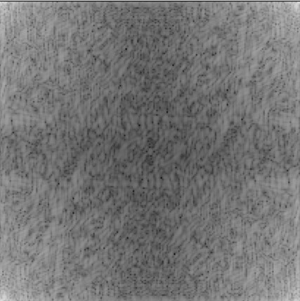

The next step, once the matrix of contrast is calculated we now have to shift it, but in a specific way, this is where we shift the zero-frequency element into the center of the spectrum matrix without losing any information in the path. 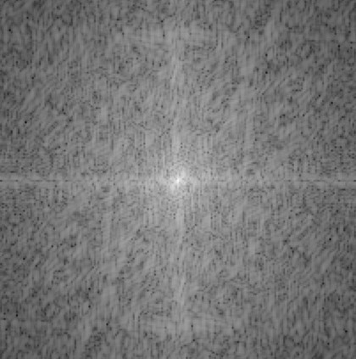

This is the point where we would apply any filters before we go further, and as for this practice it isn’t requested.

Once all filters have been convoluted, we need to put things in order as they were. The first step is to reverse the shifting process, where the centered zero-frequency component will now be at its original position. And for last to be computed again but with the inverse Fast Fourier 2-dimensional transformation. These steps look like this, and the last image is the same as the original but in (black and white) because no filters were added so all operations resetted with their respective transform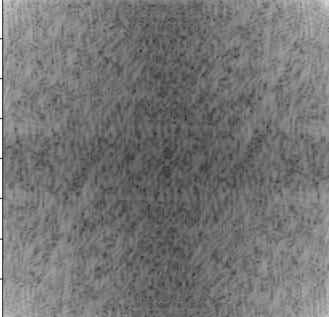

Now, for the video part I reused my previous code but with the difference that for each frame will repeat this process and save the resume of the final image. This time something strange happened. This is one result of all the ones that resulted from processing each frame of the video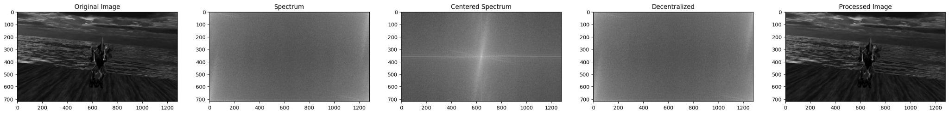

As you can see, this is the same process which each image passes through. In this sequence we’re manipulating the image and getting it ready to apply any filter we want, these changes would take place after the shifting of the spectrum. And then the image would come back as it was disposed of in pixels.

I can say that this practice was helpful while finding out how the software processes the images, both individually and frame by frame from any video feed. Also to precisely pinpoint where the filters should be used and how the filters are also programmed to process each image pixel.

# Bibliography

Chen, Craig. «Digital Image Processing Using Fourier Transform in Python». *Medium*, 9 de enero de 2021, https://hicraigchen.medium.com/digital-image-processing-using-fourier-transform-in-python-bcb49424fd82.